Narrogin Senior High School

Mathematics Department

Mathematics Applications Year 11

Test 1

Name ___________________________________________ Mark ________________

50

Instructions: ● Show all working in order for full marks to be awarded

● Round answers to 2 decimal places unless otherwise stated

● Classpads and scientific calculators are permitted

● One double sided A4 page of notes and the SCSA Formula Sheet are permitted

SCSA Objectives in this test may include:

1.1.1 calculate weekly or monthly wage from an annual salary, wages from an hourly rate, including   
 situations involving overtime and other allowances, and earnings based on commission or piecework

1.1.5 apply percentage increase or decrease in contexts, including determining the impact of inflation on

costs and wages over time, calculating percentage mark-ups and discounts, calculating GST,   
 calculating profit or loss in absolute and percentage terms, and calculating simple and compound   
 interest

**PART A – CALCULATOR FREE** Mark ____________

14

|  |  |  |  |
| --- | --- | --- | --- |
|  | **1. [4 marks: 1 mark each]** | | |
|  | Express the following percentages as decimals. | | |
| **a)** | 8.5% | **b)** | 2% |
|  |  |  |  |
| **c)** | 115% | **d)** |  |
|  |  |  |  |

|  |  |  |  |
| --- | --- | --- | --- |
|  | **2. [4 marks: 1 mark each]** | | |
|  | Convert the following to percentages. | | |
| **a)** | 0.25 | **b)** | ¾ |
|  |  |  |  |
| **c)** | 2.4 | **d)** | 1½ |

|  |  |  |  |  |
| --- | --- | --- | --- | --- |
|  | **3. [6 marks: 2 mark each]** | | | |
|  | Solve the following: | | | |
| **a)** | 30% of 150 | **b)** | 45% of 84 | |
|  |  |  |  | |
| **c)** | 15% of 24 |  |  |  |
|  |  |  |  |  |

**~ END OF TEST SECTION 1 ~**

Narrogin Senior High School

Mathematics Department

Mathematics Applications Year 11

Test 1

Name ___________________________________________

Instructions: ● Show all working in order for full marks to be awarded

● Round answers to 2 decimal places unless otherwise stated

● Classpads and scientific calculators are permitted

● One double sided A4 page of notes and the SCSA Formula Sheet are permitted

SCSA Objectives in this test may include:

1.1.1 calculate weekly or monthly wage from an annual salary, wages from an hourly rate, including   
 situations involving overtime and other allowances, and earnings based on commission or piecework

1.1.5 apply percentage increase or decrease in contexts, including determining the impact of inflation on

costs and wages over time, calculating percentage mark-ups and discounts, calculating GST,   
 calculating profit or loss in absolute and percentage terms, and calculating simple and compound   
 interest

**PART B – CALCULATOR ALLOWED** Mark ____________

36

|  |  |
| --- | --- |
| **4.** | **[4 marks: 2, 2]** |
|  | Courtney invests $25 000 at 2∙65% p.a simple interest. Calculate the following. |
| a) | How much interest would she receive if she invested it for 12 months? |
|  |  |
| b) | How long would it take for her to have $30 000 (including her original $25 000 investment)? |
|  |  |

|  |  |
| --- | --- |
| **5.** | **[4 marks: 2, 2]** |
|  | Answer the following in the spaces provided. |
|  | a) Dayna bought a house for $345 000 and sold it 5 years later for $450 000. What was her  percentage profit? |
|  |  |
|  | b) Daniel invested $5000 in a Commonwealth Bank term investment account, where the   interest rate of 5∙75% p.a. is compounded monthly. If Daniel invested this money for   5 years, how much interest would he have made? |
|  |  |

|  |  |  |  |
| --- | --- | --- | --- |
| **6.** | **[2 marks: 1, 1]** | | |
|  | A department store increases their prices to remain in line with inflation. If the rate of inflation is 2∙8%, calculate the new prices of the following: | | |
|  | a) A Wii U console with Mario Kart   originally $395 |  | b) A Dragon Quest IX DS Game $49∙95 |
|  |  |  |  |

|  |  |
| --- | --- |
| **7.** | **[4 marks: 2, 2]** |
|  | Calculate the following: |
|  | a) A shop marks all its goods up by 21%. What was the cost price for something that is   selling for $810∙70? |
|  |  |
|  | b) Jim has some radiators priced at $96 each. Since there is a new model coming out, he   marks them down to $73 so he can sell them before the new model arrives on the   scene. What is the percentage discount, rounded to the nearest 0∙1%? |
|  |  |

|  |  |  |
| --- | --- | --- |
| **8.** | **[4 marks: 2, 2]** | |
| A commercial airline buys a jumbo jet for $750 million. The value of this aircraft depreciates at a compound rate of 12∙5% p.a. | |
| 1. Find the value of the plane after 5 years, correct to the nearest million dollars. | |

1. How long will it take for the value of the jumbo jet to fall below $100 million?

|  |  |
| --- | --- |
| **9.** | **[4 marks]** |
|  | Sue’s bank account for the month of February is set out below. The account earns interest at 6∙8% p.a.    Calculate the minimum balance for February and the daily interest rate. Use this to find the interest for February, based on the minimum monthly balance. |

|  |  |
| --- | --- |
| **10.** | **[6 marks: 2, 3, 1]** |
|  | Jasmine invests $6000 for 4 years at 8% p.a. simple interest. David also invests $6000 for 4 years, but his interest rate is 7∙6% p.a. with interest compounded quarterly. |
| a) | Calculate the value of Jasmine’s investment on maturity. |
|  |  |
| b) | Show that the compounded value of David’s investment is greater than Jasmine’s investment. |
|  |  |
| c) | Explain why David’s investment is worth more than Jasmine’s investment despite receiving a lower rate of interest. |
|  |  |

|  |  |
| --- | --- |
| **11.** | **[8 marks: 1, 2, 2, 3]** |
|  | Answer the following questions using the stamp duty table below. |

[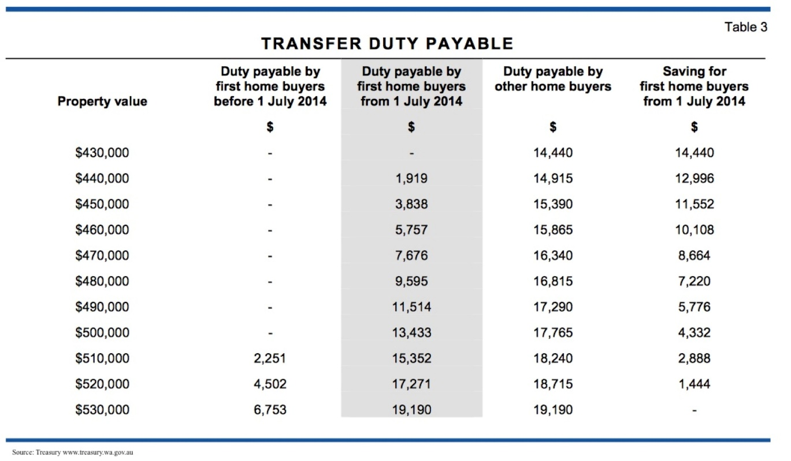](http://www.google.com.au/url?sa=i&rct=j&q=&esrc=s&frm=1&source=images&cd=&cad=rja&uact=8&ved=0CAcQjRw&url=http://whyrasmus.com/tag/stamp-duty-changes-wa-real-estate/&ei=_NmQVKX8I8PamAXF64DICA&bvm=bv.82001339,d.dGY&psig=AFQjCNG-PGKbsuW2zjlpFiGZ6Scxjy5lCg&ust=1418865463378570)

|  |  |
| --- | --- |
| a) | How much stamp duty is payable on a property valued at $520 000 if you are a first home buyer and you bought the property after 1 July 2014? |
|  |  |
| b) | What is the percentage savings on stamp duty payable if you bought a property for  $450 000 after 1 July 2014 and you are a First Home Buyer compared to duty payable by other home buyers? |

|  |  |
| --- | --- |
| c) | You bought a property for $520 000 and had $25 000 in savings. How much money would you have to borrow from the bank given you are not a first home buyer to cover the loan and stamp duty? |
|  |  |
| d) | You were offered a deal to borrow this money using a simple interest payment plan. The simple interest rate was 11% and the loan was for a 20 year period. If you pay equal monthly instalments over this 20 year period, including the interest, how much is each payment? |

**~ END OF TEST SECTION 2 ~**